Concave (converging) mirrors - 1
Help
Sheet
page
186

To draw accurate ray diagrams for these mirrors
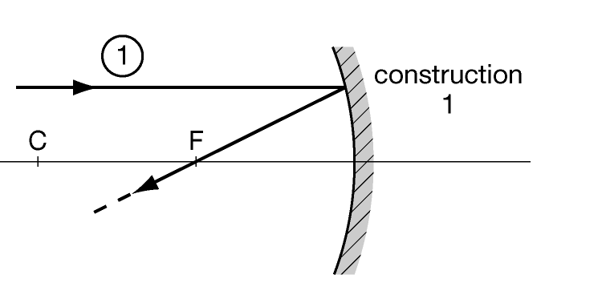
you can use 2 constructions:

Construction 1
Parallel rays of light are reflected through the
principal focus F (see Experiment 24.1 and page 172).
It is also useful to mark a point ‘C’ at twice the distance.
C is called the centre of curvature.

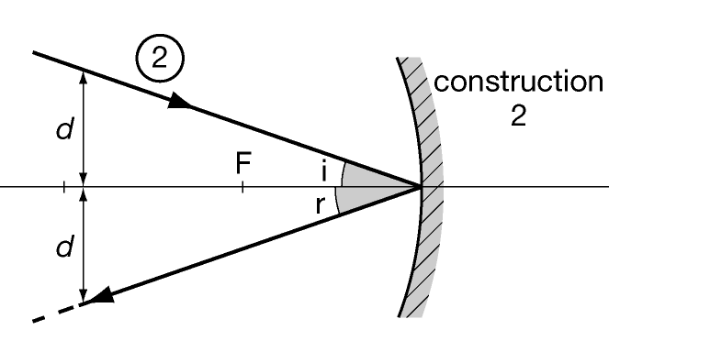
Construction 2
A ray of light travelling to the centre of the mirror is
reflected so that the angle of incidence = the angle of
reflection (i = r).
(Instead of using a protractor you can make sure that the
2 distances marked ‘d’ are equal.)
The image depends on where the object is placed.

Drawing a ray diagram
Step 1
On graph paper draw a horizontal line (called the principal axis).
Draw the mirror (near one end) as a straight line with curved ends
(to represent a small central part of the mirror).

Step 2
If distances are given to you, choose scale(s) for the object’s size and
position (often ¹/₂-scale horizontally and full-size vertically).

Step 3
Mark in the object O and the positions of F and C.

Step 4
Start from the top of the object O and draw the 2 constructions.
The position of the top of the image I is where the reflected rays cross.

Step 5
Note the position and size of the image I (using the scales if necessary).
Say whether the image is:
- inverted or erect,
- magnified (bigger) or diminished (smaller),
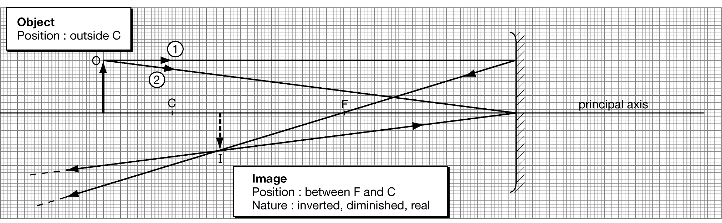
- real (rays actually go through the image) or virtual.

